**Inventory Accounting:**

Inventory accounting is the body of accounting that deals with valuing and accounting for changes in inventoried assets. A company's inventory typically involves goods in three stages of production: raw goods, in-progress goods, and finished goods that are ready for sale.

**Gateway of Tally**

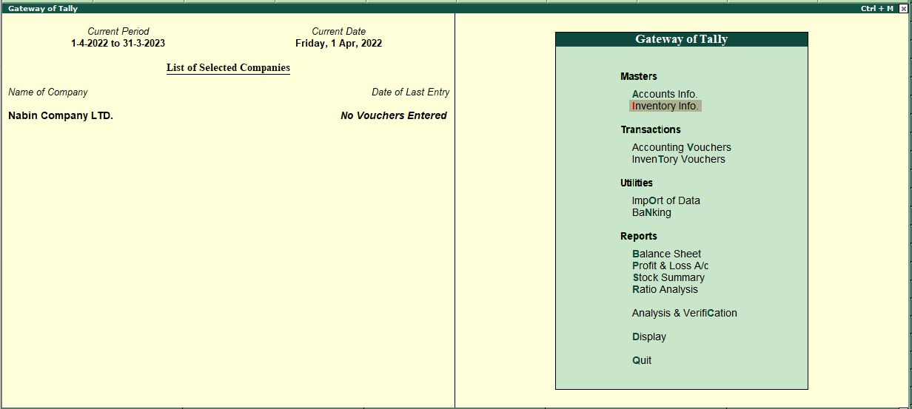

**Stock Groups:**

Stock Groups in Inventory are similar to Groups in Accounting Masters. They are helpful in the classification of Stock Items. You can group Stock Items under different Stock Groups to reflect their classification based on some common features such as brand name, product type, quality, and so on. Grouping enables you to locate Stock Items easily and report their details in statements.

The path of stocks groups is:

* ***Go to Gateway of Tally >> Inventory Info>> Stock Groups***.

**Stock Group Creation:-**

* Go to **gateway of tally** and Click on **inventory info**

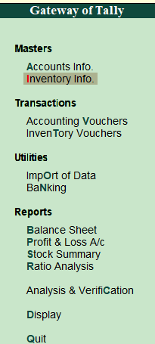 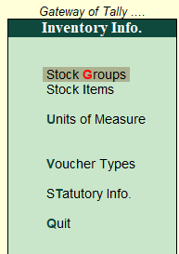

* Click on **stock** **groups**.



* Then, create a stock group **(Under single stock group).**

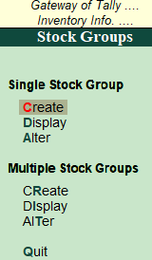

* And create different **inventory heading.**

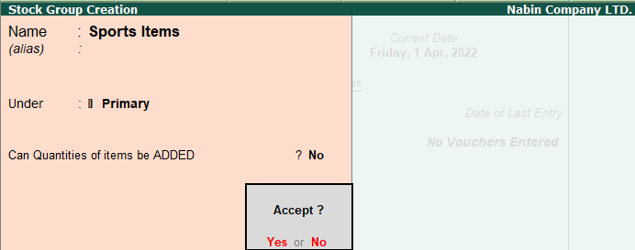

**To create a stock group.**

1. Enter the **Name of the Stock Group** to be created. For example: sports Items.

3. Enter additional name apart from primary name [if required] in the field **Alias.** You can create any number of additional names.

4. Specify whether it is a primary group or a sub-group of another group in the field **under,** by selecting from the list.

5. Press **Alt+C** to create a parent group, if you do not have it in the list.

**Different Stock groups of Nabin company LTD.**

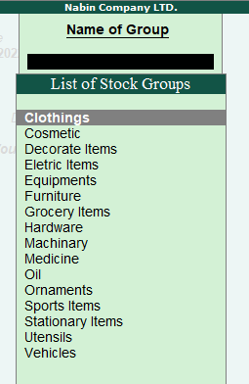

* Then, create a stock group **(Under multiple stock group).**
* ***Go to Gateway of Tally >> Inventory Info>> Stock Groups>>cReate***.

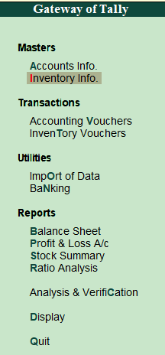 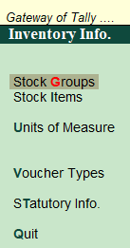 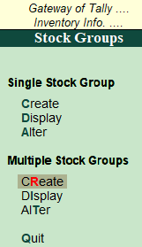

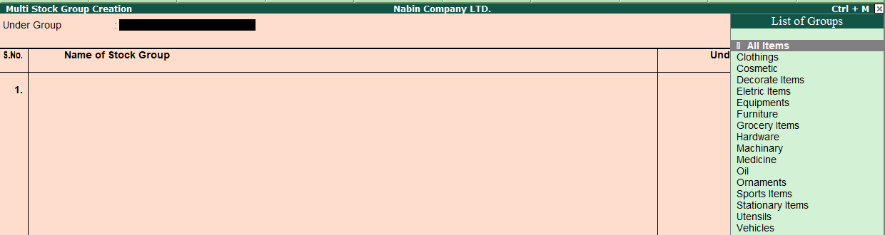

Displaying of multiple stock group.

  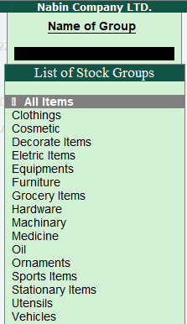

**Units of Measures:**

The unit of measure concept is a standard convention used in accounting, under which all [transactions](https://www.accountingtools.com/articles/2017/5/15/transaction) must be consistently recorded using the same [currency](https://www.accountingtools.com/articles/2017/5/4/currency). For example, a business maintaining its records in the United States would record all of its transactions in U.S. dollars, while a Nepalese company would record all of its transactions in NPR.

# Creating Unit of Measure.

* Go to **Gateway of Tally** Click on **Inventory Info.**

 

* Click on **Units of Measure.**

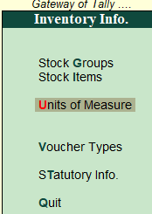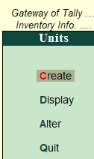

* And click on **Create.**

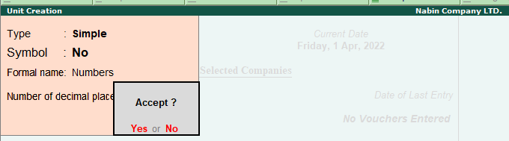

The unit of measure are created as:

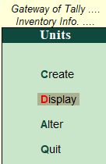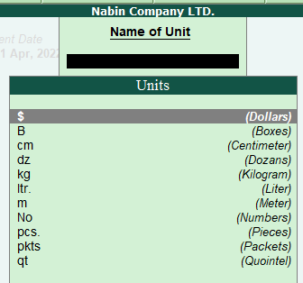

**Stock Items:**

Stock Item refers to goods that you manufacture or trade. It is the primary inventory entity and is the lowest level of information on your inventory. Items in the inventory transaction are similar to ledgers being used in accounting transactions. Therefore, stock items are important in an inventory just as ledgers are important in accounting.

**Stock Items Creation**

* Go to **gateway of tally and** Click on **inventory info.**

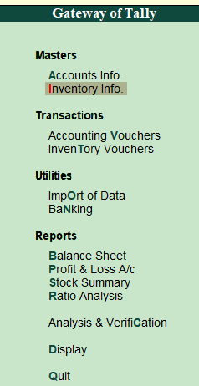

Click on **stock items than** Click **create** of **Multiple Stock Items**

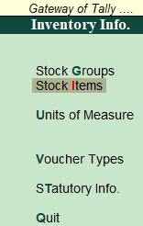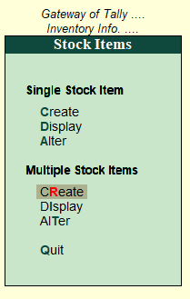

**To create a Stock Item in different Inventory Head.**

* Specify the **Name of the Stock Item**.
* Specify the **Alias name of Stock item (if required).**
* The field **Under** will show the **List of Groups**. Here you can select the Stock Group to which the Stock Item belongs. By default, Primary Stock Group appears in this field.

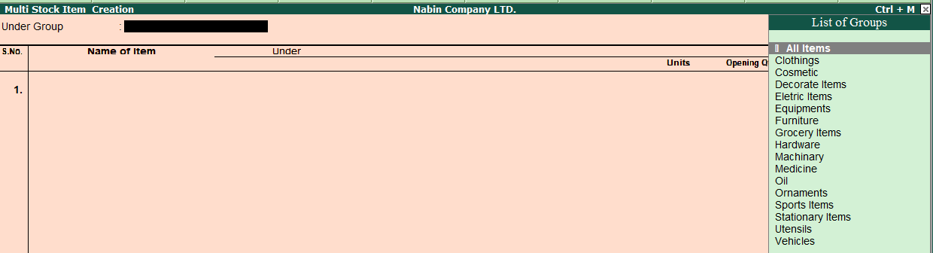

**Different stocks items of Nabin company LTD.**



